

Name: Karan Kr. Pal PRN: 25070122098
Branch: CSE (25–29)
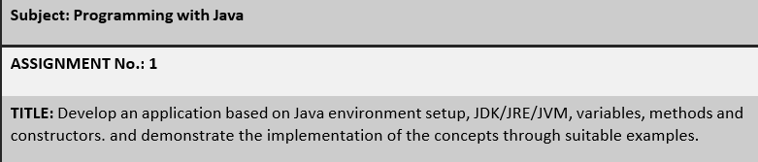
Semester: 3

Problem Statement:
Develop a Java-based application that demonstrates Java environment setup, JDK, JRE, JVM, variables, methods, and constructors through appropriate examples.

Learning Objectives:
To understand the theoretical concepts, implement them using Java programs, examine the generated outputs, and apply these concepts to solve practical programming problems.

Theory:
Java environment setup, JDK, JRE, JVM, variables, methods, and constructors are essential parts of Java programming. Students should understand their basic concepts, architecture, benefits, use cases, and implementation techniques. This exercise focuses on design principles, proper coding practices, program execution flow, and the practical use of these concepts in software development. The detailed study includes syntax, important APIs, the execution process, and real-life applications.

Screenshots:

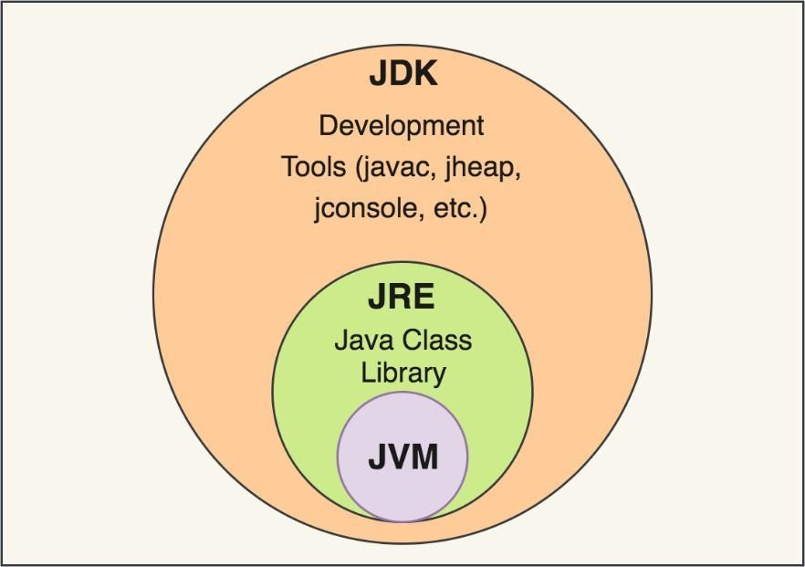
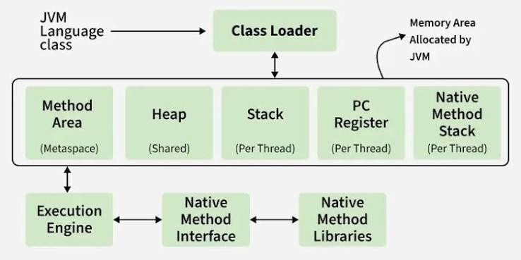

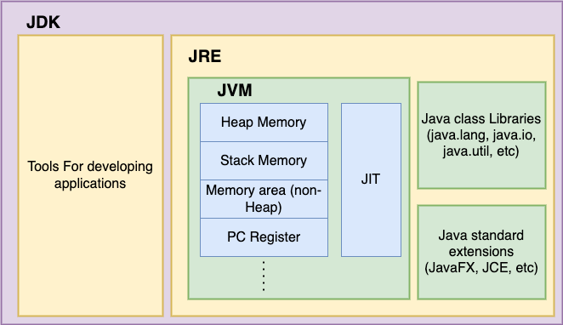

JVM (Java Virtual Machine)
The JVM is responsible for running Java bytecode stored in .class files on a computer system. It translates platform-independent bytecode into machine-level instructions that can be understood by the operating system. It acts as the main execution engine and is the innermost part of the Java platform.

JRE (Java Runtime Environment)
The JRE contains the JVM along with the Java Class Library, which includes commonly used built-in packages such as java.util and java.io. It provides all the necessary components required to execute a Java application. However, it does not provide tools for writing or compiling Java programs. Therefore, the JRE is mainly suitable for users who only need to run existing Java applications.

JDK (Java Development Kit)
The JDK consists of the JRE along with various development tools such as javac, jconsole, and jheap. It provides a complete environment for writing, compiling, debugging, and executing Java programs. Hence, Java developers must install the JDK because it includes both the JRE and the JVM.

Conclusion:
The diagram represents JDK, JRE, and JVM as interconnected and nested components rather than separate tools. The JVM executes Java bytecode, the JRE provides the required class libraries for running Java applications, and the JDK adds development tools used for writing and compiling programs. This relationship can be represented as JDK ⊃ JRE ⊃ JVM. End-users generally require the JRE to execute applications, whereas developers need the complete JDK.

Questions:
- Explain the main concepts used in Java environment setup, variables, and methods.
Java environment setup begins with installing the JDK, which provides the tools required to create, compile, and execute Java programs. After setting up the environment, variables are used to store different types of information, such as

numbers, text, characters, or decimal values. Methods are reusable blocks of code designed to perform a particular operation. Variables store the required data, while methods process or perform actions on that data. Together, they form the
fundamental structure of a Java program.

What are the advantages of using Java variables and methods?
Variables help in storing, accessing, and managing data in an organized manner. They improve the readability of a program by giving meaningful names to stored values. Methods divide a large program into smaller and manageable sections, which reduces repetition of code. They also make debugging, testing, and maintenance easier because modifications can be made within a specific method instead of changing the complete program. The same method can also be called several times with different values, improving code reusability and efficiency.

What are the real-world applications?
Java variables and methods are used in many real-world applications. In banking software, variables can store customer details, account balances, and transaction amounts, while methods perform operations such as deposits, withdrawals, and balance checks. In e-commerce applications, variables store product names, prices, and quantities, whereas methods handle shopping carts, order calculations, and payments. They are also used in Android applications for login verification, user data management, and input validation. Enterprise software, games, educational applications, and automation systems also depend on variables and methods for organized data handling and reusable program logic.

